Case 1:

MobileEntity:

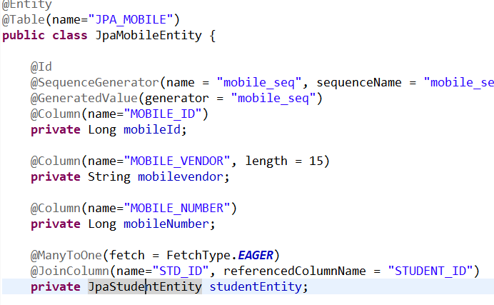

StudentEntity:

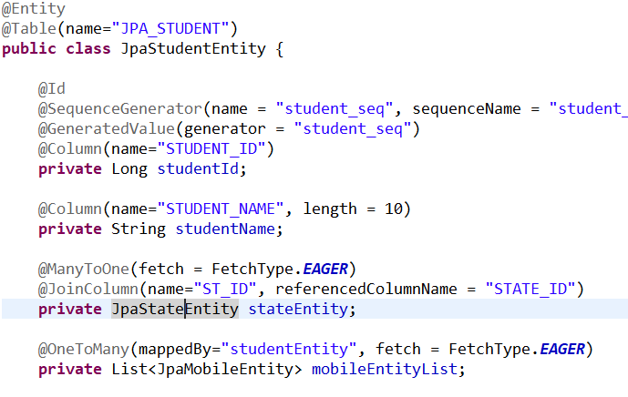

StateEntity:

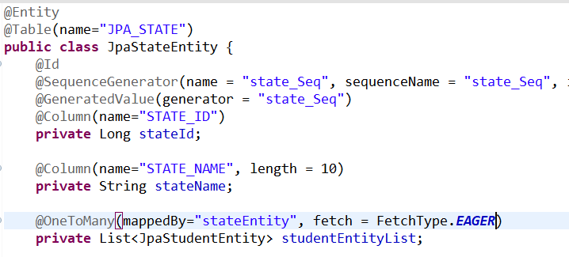

Operation 1 : Fetch Mobile by mobile-id

SQL query generated :

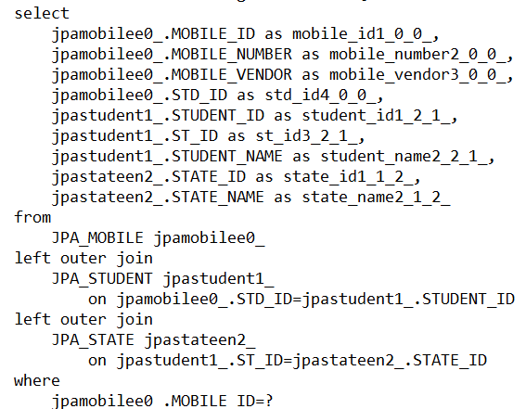

This query will be generated to find the SINGLE interconnected Student entity and State entity along with the specific mobile entity whose id is 3. Suppose state-id fetched is 1

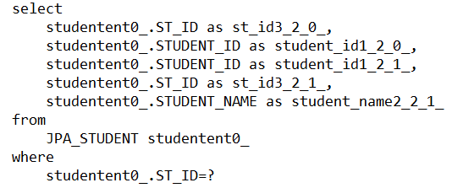

This query will be generated to find the list of Student entities under state-id 1

Suppose fetched student-entity ids are 1,2 and 3

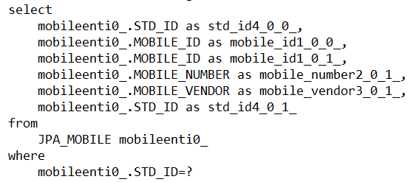

This query will be fired 3 times for student-id 1,2 and 3(fetched by previous query) to fetch the list of mobiles under each student-id.

Operation 2 : Fetch all mobiles

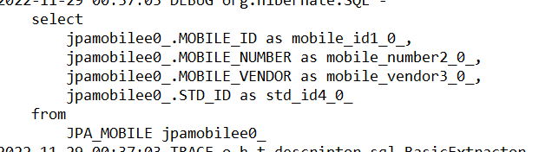

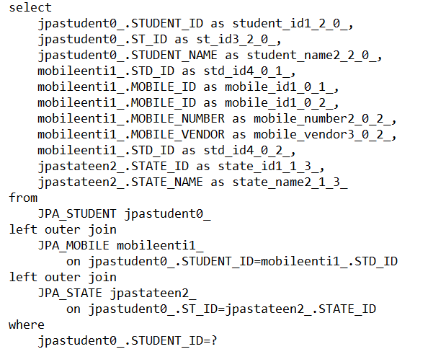

This query will be fired 5 times for student-id 1,2 ,3,4 and 5(fetched by previous query) to fetch the connected student and state against a particular mobile

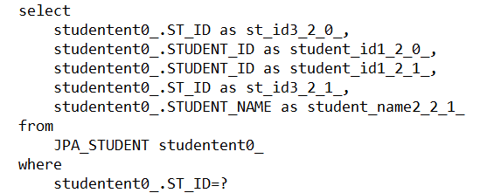

This query will be fired 2 times for state-id 1 and 2 (fetched by previous query) to fetch the list of students under a particular state

SEARCH BY STATE

Case 1 :

State Table :

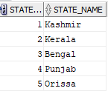

Student Table :

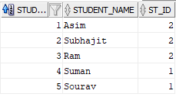

Mobile Table :

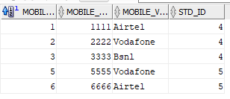

StateEntity :

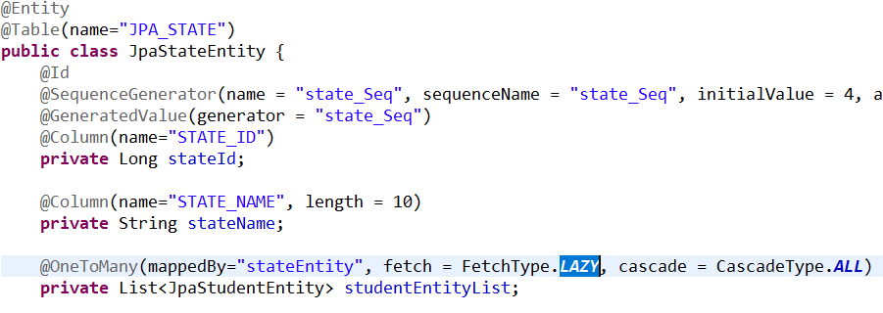

StudentEntity :

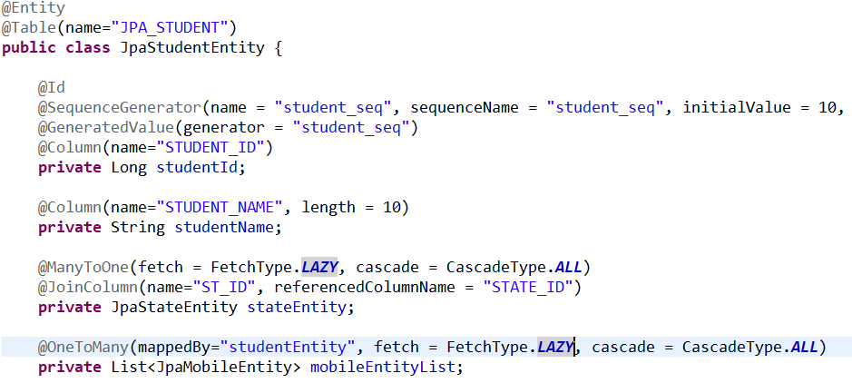

MobileEntity :

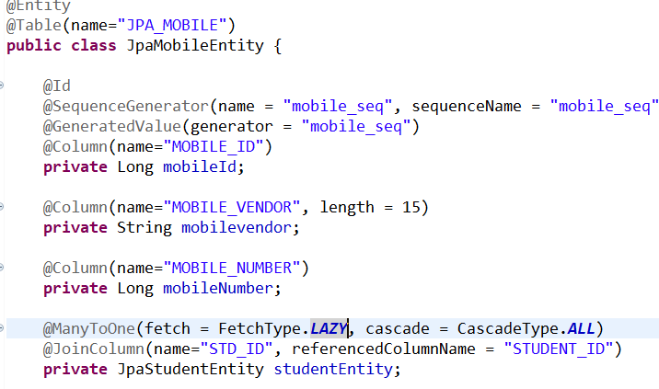

Query 1 :



SQL generated :

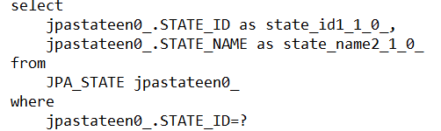

Output :



Query 2 :

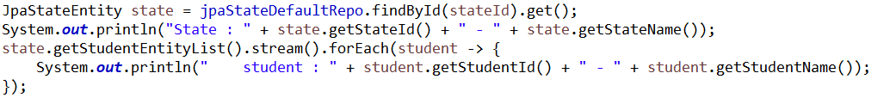

SQL generated :

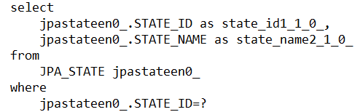

Output :



SQL generated on 2nd hit :

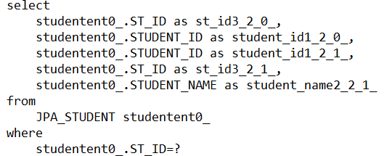



Output :



Query 3 :

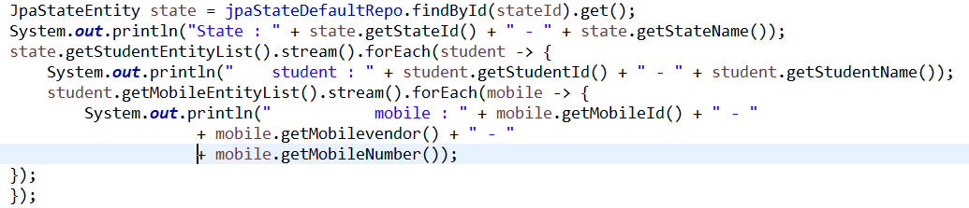

SQL generated :



Output:



SQL generated on 2nd hit :





Output :



SQL generated on 3rd hit:

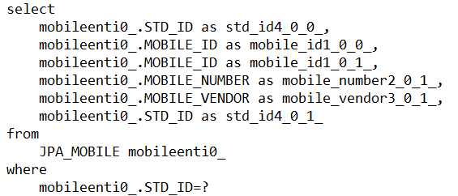



Output:

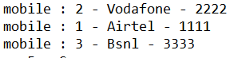

SQL generated on 4th hit:





Output:



Case 2 :

Table data remaining same

StateEntity :

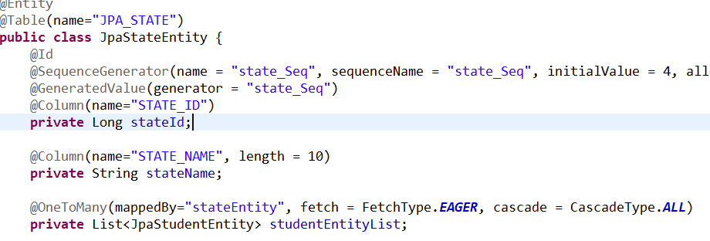

StudentEntity and MobileEntity remaining same

Query 1:



SQL Query generated:

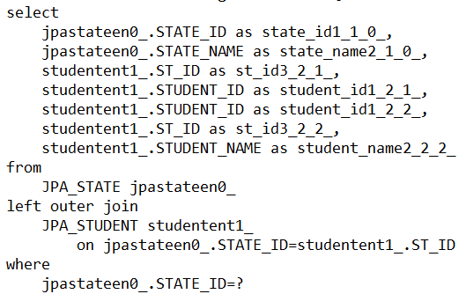

Output :



Query 2:



SQL query generated :



Output :

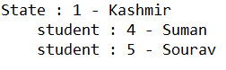

Query 3:



SQL query generated :



Output :



SQL query generated on 2nd hit :



Output :

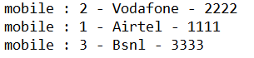

SQL query generated on 3rd hit:





Output :



Case 3 :

Table data remaining same

StudentEntity:

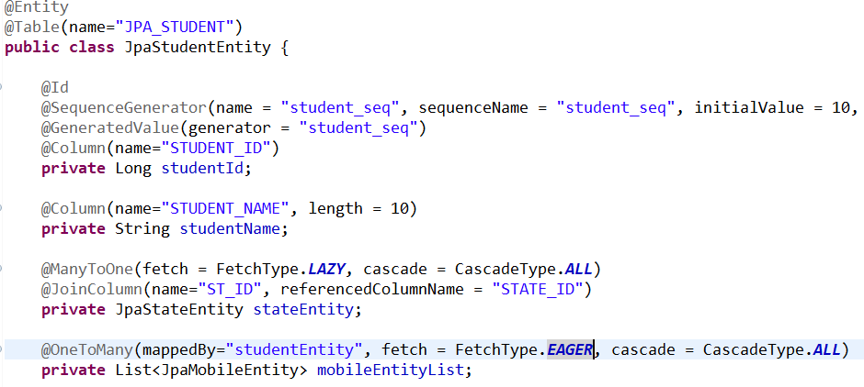

StateEntity and MobileEntity remaining same

Query 1 :



SQL query generated:

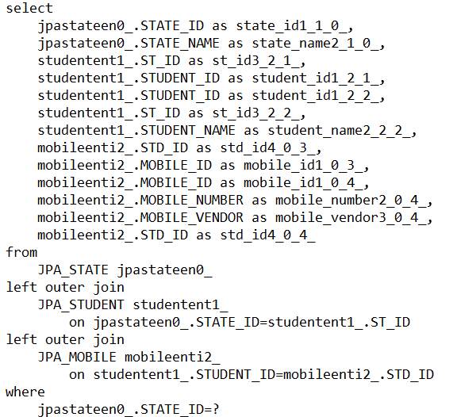

Output :



Query 2 :



SQL query generated:



Output :

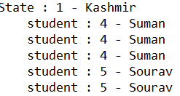

Query 3 :



SQL query generated:



Output :

